Summary of Activities

1. Installed ESXI on each host (steps not shown, just notes)
2. Deleted Old Datastores leftover from old build on the NVMe drives (steps not shown, just notes)
3. Cleared the partitions on the NVMe drives (steps not shown, just notes)
4. Configured NTP servers
5. Started ntpd service
6. Enabled SSH on all three hosts
7. Disabled USB arbitrator to allow USB flashdrives to be seen as storage (not to be used in enterprise environments)
8. Added USB “Fling” driver for USB to Ethernet driver support (not to be used in enterprise environments)
9. Set host name and domain name
10. Key takeaways
11. Results
12. Installed ESXI on all three hosts.
13. Deleted old datastores on all three hosts
14. Cleared partition table on all three host's NVMe drives from old lab build
15. Configured NTP settings on all three hosts.  
    1. Navigator > Manage > System > Time & Date
    2. **Edit NTP Settings**
    3. Selected **Use Network Time Protocol (enable NTP client)**
    4. NTP service startup policy set to **Start and stop manually**
    5. NTP Servers set to **0.north-america.pool.ntp.org, 1.north-america.pool.ntp.org, 2.north-america.pool.ntp.org, 3.north-america.pool.ntp.org**   
       Graphical user interface, text, application, email

       Description automatically generated
    6. Click **Save**.  
         
       (Documentation of steps continues on next page)
16. Started **ntpd** service on each host  
    1. Navigator > Manage > Services
    2. Right-click on **ntpd** and clicked **Start**
    3. Validated it showed running.  
         
       
    4. Validated UTC time matched current UTC time. *Host > System Information*
17. Enable SSH for each host in preparation for custom options  
    1. Navigator > Host
    2. Click on **Actions**
    3. Hover on **Services** in the drop-down menu
    4. Select **Enable Secure Shell (SSH)**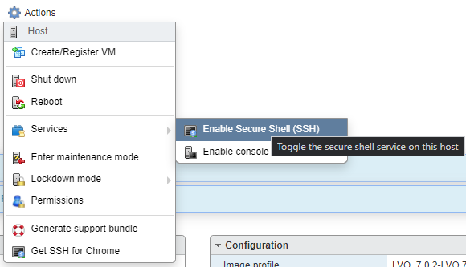
18. Disable USB Arbitrator Service (this can also be done via CLI) – **SKIP THIS IF NOT USING USB devices for Datastores.**
    1. Navigator > Manage > System > Advanced Settings
    2. Graphical user interface, application, Word

       Description automatically generatedClick in Search Textbox, type **usb.arb**
    3. Click on *USB.arbitratorAutoStartDisabled* and then click on **Edit Option** at the top.
    4. Set **USB.arbitratorAutoStartDisabled** to **1**
    5. A restart of the Esxi host will be required to apply this change. This will allow USB devices to be seen directly by the Esxi host to be used as storage devices. Note that this is NOT recommended to be used in an enterprise environment.  
         
       (Documentation of steps continues on next page)
19. Installing USB to Ethernet Driver (Fling) – **Skip if not using USB to Ethernet adapters**
    1. Click on your available Datastore under **Storage** in the navigator
    2. Click on **Datastore Browser**
    3. Click on **Create Directory**Graphical user interface, text, application

       Description automatically generated
    4. Directory name should be **FlingDriver**. Click on **Create Directory**.  
         
       Graphical user interface, text, application, email

       Description automatically generated
    5. Click on the **FlingDriver** directory. The upload button should now be green.
    6. Click on **Upload** (Steps continued on next page)
    7. Upload the zip file you have (fully zipped no need to extract). It should now show in the directory.  
         
       Graphical user interface, application

       Description automatically generated
    8. Connect to host via SSH
    9. Place host into maintenance mode: **esxcli system maintenanceMode set -e true**
    10. Locate the zip file you uploaded within the CLI. It should be under **/vmfs/volumes/<VOLUMENAME>/FlingDriver/<NAME-OF-FILE>.zip**
    11. Note, before you attempt to run the next command. If there is a pending reboot, the machine MUST be rebooted prior to installing the USB NIC driver.
    12. Note, your USB to Ethernet NIC should **NOT** be plugged in. If the command below is failing, unplug the USB to Ethernet NIC and reboot. Make sure to re-enable SSH
    13. 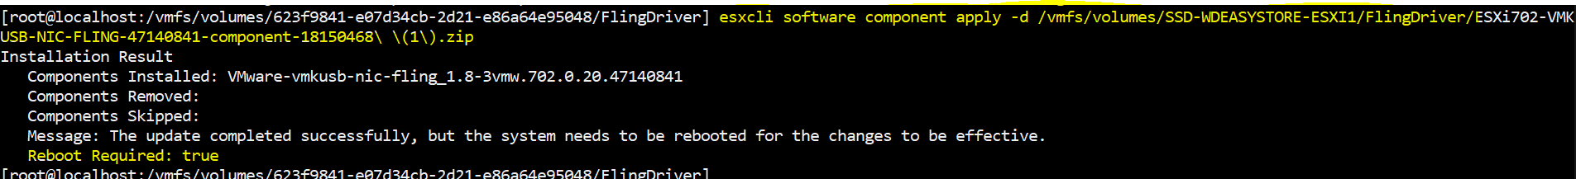Run: **esxcli software component apply -d /vmfs/volumes/VOLUMENAME/FlingDriver/FLINGDRIVERPACKAGENAME.zip**Note: Replace the **red** with your actual volume name and when you get to *Flingdriver/*just hit TAB, it will autocomplete the entire file name – and yes… you need to use the full directory path, even if you are in the same directory.
    14. Type **Reboot** to reboot your ESXi machine.
    15. Note, I believe this package can also be installed via the web browser through **Manage > Packages > Install Update**, same thing as in the CLI, you have to use the exact directory of the zip file.
    16. To validate that it installed. Log in to the web console of the esxi host directly and go to **Manage > Packages**. On the right side of the Packages interface, there is a search bar. Search for “fling” and the **vmkusb-nic-fling** package should appear after the reboot.
    17. Click on **Networking** in the Navigator
    18. Click on **Physical NICs** (plug in your USB to Ethernet NIC now, it’s safe to do so)
    19. Your USB to Ethernet NIC should now be showing as **vusb0**.  
          
        (Documentation of steps continues on next page)
20. Renaming the hosts  
    1. Log into the web client
    2. Place host into maintenance mode
    3. Click on Networking in the Navigator
    4. Click on **TCP/IP stacks**
    5. Click on **Default TCP/IP stack**Graphical user interface, text, application, email

       Description automatically generated
    6. Click on **Edit Settings**Graphical user interface, text, application

       Description automatically generated
    7. Click on **Manually configure the settings for this TCP/IP stack**
    8. NOTE: I had already reserved the IP address on my Edgerouter-X for each host and my router supports DNS forwarding.
    9. Set Hostname to whatever you wish to name the host, in my case, **esxi1**.
    10. For the **Domain Name** if you own one, you may use it. However, **local** is…. Ok if you have nothing else. I will be using **ad.jakeyuhas.com** as I own that domain and nobody else can control the DNS records but myself.
    11. For the **Search Domains** I used **ad.jakeyuhas.com**Graphical user interface, application

        Description automatically generated
    12. Primary DNS server, IPv4 Gateway, Congestion Control, Maximum number of connections I left to default.
    13. I repeated this step for each host.
21. Key Take Aways from this Lab That I wrote and what I learned performing these steps a 2nd time.  
    1. Disable Secure Boot for Lenovo M720Q (tiny) computers since Esxi does not know how to interact with it on this platform. The Lenovo M920Q host was able to recognize the Secure Boot and did not cause an interrupt during boot.
    2. After setting the USB Arbitrator to disabled, I was unable to install the Fling driver. I had to reboot before installing a new package. Again, this could be something to do with utilizing consumer hardware for a ESXi. – The second theory is that a USB to Ethernet device was plugged in when attempting to install the package; which probably caused a volume to be locked. – I am unsure of exactly what the issue was but with anything in IT, rebooting seems to fix the issue.
    3. ESXi hosts were immediately picked up by DHCP and given a lease. I went into my EdgeRouter-X and went ahead and reserved the IPs each host picked up and bound it to each host’s MAC address so they remain static and always remain to have that IP address.
22. Results  
    1. Browsers reflecting new hostname FQDN  
         
       
    2. Graphical user interface, application

       Description automatically generatedEsxi1.ad.jakeyuhas.com Host summary:
    3. Graphical user interface, application

       Description automatically generatedEsxi2.ad.jakeyuhas.com Host summary
    4. Graphical user interface, application

       Description automatically generatedEsxi3.ad.jakeyuhas.com Host summary
    5. Graphical user interface, text, application, email

       Description automatically generatedSandisk USB drive appearing via Local USB Direct Access
    6. Graphical user interface, text, application

       Description automatically generatedVusb0 appearing as an available network device (USB to Ethernet adapter)